INFECTION CONTROL  
PROTOCOL 002

short line  
  
IMMERSIVE ENVIRONMENTS   
OCTOBER 2022

# CONTENTS

1. ROLES AND RESPONSIBILITIES, P. 2
2. HAND WASHING, P. 2
3. MASK DONNING, P. 3
4. PERSONAL PROTECTIVE EQUIPMENT, P. 3
5. SET UP, P. 3
6. SKIN PREPARATION, P. 4
7. PIERCING, P. 4
8. BREAKDOWN, P. 5
9. BIO ASSISTANT, P. 5
10. RIGGING WITH CORD, P. 5
11. PROCESSING HARDWARE, P. 6
12. DONNING PERSONAL PROTECTIVE EQUIPMENT, P. 7
13. POST SUSPENSION, P. 7
14. HOOK PROCESSING, P. 9
15. BLOOD CLEANUP, P. 9
16. SUTURING PROTOCOL, P. 9
17. BLOOD / OPIM EXPOSURE, P. 10
18. HANDLING CONTAMINATED WASTE, P. 10
19. GENERAL GUIDELINES, P. 10

# 

# 

# ROLES AND RESPONSIBILITIES

Immersive Environments and its workers need to observe very high standards of hygiene to reduce the risk of blood borne, or other, infections, in order to keep everyone healthy and safe.

Specified volunteer roles include:

1. **CLEAN ASSISTANT (CLEAN):** Responsible for the handling of supplies with *clean* gloved hands only except in the assistance of hook removal.
2. **BIO ASSISTANT (DIRTY):** 
   1. Responsible for the handling of all contaminated items and individuals. Specific personal protective equipment (**PPE**) requirements, set out below, are to be adhered to; and
   2. Responsible for blood spotting on an individual while a suspension is taking place.
3. **PIERCER:** Responsible for the safe and aseptic piercing of all individuals to be suspended.
4. **RIGGER**: Responsible for the aseptic handling of any rigging - specific to the rig plate down.

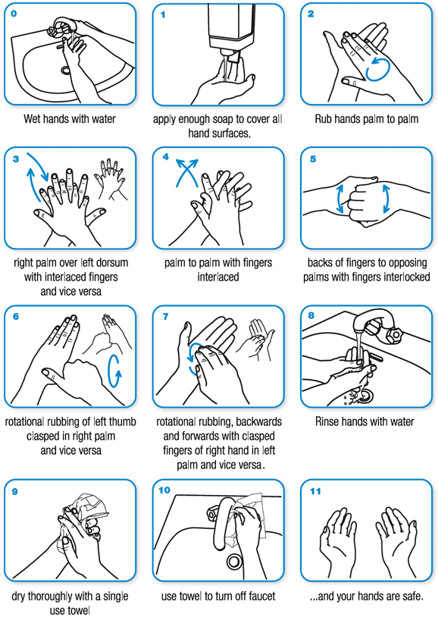

HAND WASHING

This is a diagram of appropriate hand washing procedure. This is to be done at the beginning of any preparation, piercing or handling of any individual to be suspended as well as after eating, smoking or using the bathroom.

MASK DONNING

1. Ensure your face mask is clean and dry and is not damaged.
2. Before putting on your face mask, clean your hands with soap and water or use hand sanitiser (containing at least 60 percent alcohol). Ensure your hands are dry.
3. Place the face mask over your nose and mouth and secure it with ties or loops. Make sure the mask fits snugly, molded to your face and around your nose. Make sure the mask fully covers your nose, mouth and chin. Your mask should be comfortable, with no gaps around the mask and your face, and allow you to breathe easily.
4. Clean your hands again (as above).

# PERSONAL PROTECTIVE EQUIPMENT

All PPE is provided by IE.

1. **EYEWEAR** - disinfectable after each use
2. **FACEMASK** - single use, disposable
3. **EXAM GLOVES** - single use, disposable
4. **STERILE GLOVES** - single use, disposable
5. **PLASTIC APRONS** - single use, disposable
6. **PLASTIC SLEEVES** - single use, disposable

# SET UP

The volunteer that is setting up must don a face mask, wash their hands then don exam gloves.

1. **FOR PIERCING:** hooks, needles, sterile drape, sterile gloves (if applicable), gauze, marker, lubricant.
2. **FOR POST SUSPENSION:** gauze, patches and lubricant.

**CLEAN ASSISTANT:**

1. Don mask and exam gloves.
2. Bring any necessary supplies from the supply table.
3. Ensure they have no direct contact with the dirty massage table, suspendee or dirty worker.
4. Bring all piercing disposables (listed above) to the work area and carefully place them on the work tray.

# SKIN PREPARATION

The nominated volunteer is to:

1. Don a clean mask and exam gloves.
2. Massage the tissue to be pierced to break up the skin layers and soften the area.
3. Change exam gloves and have a clean assistant hand you skin cleaner on sterile gauze.
4. Apply the skin cleaner between where the hook will enter and exit in circles, spiraling out beyond the hook placement in all directions - this is to first **clean** the surface of the skin.
5. Change exam gloves.
6. Proceed with marking. Mark, then allow ink to dry.
7. Change exam gloves.
8. Have the clean assistant add skin cleaner to gauze.
9. Apply the skin cleaner between where the hook will enter and exit in circles, spiraling out beyond the hook placement in all directions - this is to **disinfect** the surface of the skin.

# PIERCING

The piercer(s) is to:

1. Don your mask, eyewear and gloves.
2. Peel open the sterile drape on the work tray and use it as a sterile field (alternatively, the sterile glove wrapper can be used in place of a separate sterile drape).
3. Open hook packs and needle packs away from themselves and gently drop onto the sterile field.
4. Open sterile lube onto sterile drape.
5. Don sterile OR exam gloves.
6. Pick up hook and needle, lube the tip of the needle then insert hook into needle end.
7. Pierce suspendee and dispose of needle immediately after into sharps container. Repeat for all piercings.

# BREAK DOWN

The nominated volunteer is to:

1. Don exam gloves.
2. Ball up any paper waste on the tray and set this onto the drape sheet on the massage table and ball it up.
3. Keeping everything contained, carefully place into contaminated waste bin
4. Change exam gloves.
5. Get disinfectant wipes and wipe the surface starting at one end, in a side-to-side motion, from one end to the other, extending over both sides. This applies to the massage table and work tray. Allow it to dry.
6. Dispose of gloves and wipes.
7. Don new gloves then place a new drape on the massage table – put a green tag on both the table and tray.

# BIO ASSISTANT

The bio assistant is to:

1. Don mask and gloves and have new gauze ready.
2. Only wipe blood from the suspendee that is visibly running. If wiping is needed, ensure you wipe away from the wound so as to not drag contamination into the wound.
3. Pay attention to the suspendee at all times to avoid any unnecessary contamination.

# RIGGING WITH CORD

The rigger is to:

1. Always avoid contaminating the rig where possible. The use of shackles can help with this. In this scenario, the bio-assistant can attach the line with the shackles to the hooks and the rigger can remain without gloves, attaching the line to the rig.
2. Have a volunteer hold the rig steady attaching lines if needed. If there is potential for the rig to become contaminated while rigging, have the volunteer don gloves.
3. Be careful when rigging not to run the cord near the hook wounds as this can contaminate the cord with visible blood.
4. Gloves must be worn when adjusting tension on the cord.

# PROCESSING HARDWARE

The nominated volunteer is to:

**RIGGING AND SHACKLES**

1. Don exam gloves and get a disinfectant wipe.
2. Remove shackles from hooks and thoroughly wipe the shackles / hooks then place the shackles / hooks in the designated container.
3. Change exam gloves.
4. Cut the contaminated cord as close to the rig as possible and dispose of the cord in the contaminated waste bin.
5. Change exam gloves.
6. Get another disinfectant wipe.
7. Start at one end of the rig and wipe all surfaces with the disinfectant wipe while the rig is still hanging. Repeat if the rig is too large for one go or has visible contamination. (alternatively, the rig can be disconnected and taken to the decontamination table for later disinfection).
8. Allow the rig to dry then disconnect.

**HARDWARE**

1. Don gloves and get a disinfectant wipe.
2. Wipe all surfaces and place the hardware on the clean side of the decontamination table.
3. Once the hardware is dry, return to the hardware table.
4. Scissors may be reused unless visibly contaminated.

DONNING PPE

1. Put on a mask, eyewear and apron.
2. Don gloves and put on apron sleeves by poking a hole for the thumb near the cuff then put on a second pair of gloves over sleeves.

# POST SUSPENSION

**PREPARATION**

1. The nominated volunteer is to designate clean and bio assistants. Bio assistants to don PPE (see above).
2. In the case of hooks for personal use, the clean assistant should ensure there is a snap lock bag with enzymatic gel and a plastic container ready (**snap lock bag**).
3. If needed, bio assistant to lube the entry and exit wounds with a small amount of sterile lubricant.
4. The clean volunteer is to open the gauze.

**HOOK REMOVAL AND WOUND CLEAN– BIO ASSISTANT**

1. The bio assistant is to perform the following steps for each wound:  
   1. Remove hook.
   2. Give the hook to the clean assistant.
   3. Cover the wound with gauze.
   4. Immediately apply pressure to the wound.
   5. Massage the air out of the wound while keeping gauze over wounds.
   6. When it's clear bleeding is under control (not flowing), move onto the next hook.
   7. Repeat until all hooks are out and repeat for all wounds.
   8. Once all hooks have been removed - in circular motions, starting at the inside, clean the area around the holes with soapy water-soaked gauze to remove any dried blood. Dry with clean gauze if necessary.
   9. Remove outer gloves.

**HANDLING CONTAMINATED HOOKS – CLEAN ASSISTANT**

1. The clean assistant is to:  
   1. Have disinfectant wipes ready.
   2. Receive the contaminated hooks from the bio assistant.
   3. Use the disinfectant wipe to remove any debris from the hooks.
2. Place the hooks in the designated hook container or the snap lock bag.
3. In the case of hooks for personal use the clean assistant is to:
   1. Change exam gloves.
   2. Place hooks in the snap lock bag.
   3. Seal snap lock bag.
   4. Change exam gloves.
   5. Place the snap lock bag into another snap lock bag then into the plastic container.
   6. Seal the plastic container with masking tape.
   7. Name the container.
   8. Hand the container to the suspendee.

**WOUND TREATMENT – CLEAN ASSISTANT AND BIO ASSISTANT**

1. After the bio assistant has removed all hooks and cleaned the wounds with soapy water, the clean assistant is to:
   1. Open the bandages and remove them from the package, ensuring the sterile pad is not touched, then hand the bandage to the bio assistant.
   2. Repeat for all wounds.
2. The bio assistant is then to:  
   1. Without touching the wounds with their gloves, cover the wound with the bandage and apply pressure.
   2. Repeat for all wounds.
   3. Clean tray and table as defined in the break down section then remove PPE (apron > sleeves > gloves > mask > eyewear) and dispose of single use items in contaminated waste bin. Disinfect eyewear if visibly contaminated.

In conditions where numerous wounds need to be dressed, additional assistants may be required.

It may also be acceptable for an experienced team member to adjust this protocol accordingly, where both roles may be consolidated.

# HOOK PROCESSING

1. Hooks are wiped free of any blood and opim (other potential infectious matter).
2. Hooks are to be covered in enzymatic gel after being wiped to prevent any matter drying to the hooks.
3. Hooks are then rinsed, dried then placed in a biohazard container to then take to sterile services for processing and sterilisation.

# BLOOD CLEANUP

A nominated bio-assistant is to:

1. Warn those in the area to avoid making contact, then don gloves.
2. Get a paper towel, clean up excessive blood spill then change gloves.
3. Get a disinfectant wipe to clean the area down from side to side ensuring not to spread the contamination then allow it to dry.

# SUTURING PROTOCOL

In circumstances where suturing is required the health and safety officer (Eden) is to be notified. Eden will then nominate a volunteer to suture the wounds.

The nominated volunteer is to:

1. Wash hands and don full PPE.
2. Have a clean assistant set up a tray with sterile gloves and suture kit.
3. Open sterile gloves, using the pack as a sterile field. unpack all other sterile supplies and place them on the sterile field.
4. Don sterile gloves employing aseptic technique.
5. Once suturing is done, clean the surrounding area with soapy water and gauze as well as dry gauze.
6. Follow the breakdown procedure.

# BLOOD / OPIM EXPOSURE

If you injure yourself with a used sharp, or were exposed in some other way to someone else’s blood or body fluid, immediately follow these steps:

**SHARPS INJURY:**

1. Inform the health and safety officer (Eden) and remove yourself from the area.
2. At the hand wash sink, encourage the wound to bleed by holding it under running water.
3. Wash the wound with soap and water.
4. Do not scrub the wound while you are washing it.
5. Dry the wound and cover with a waterproof plaster.
6. Disinfect the sink once able to - warn others it is contaminated.
7. The health and safety officer (Eden) will fill in an incident report form.
8. Fill in an exposure form and seek medical attention if needed.

**IF SPLASHES TO THE NOSE, EYES, MOUTH OR SKIN:**

1. Flush these areas with running water.
2. Report the incident to the health and safety officer (Eden).
3. Fill in an exposure form and seek medical attention if needed.

# HANDLING CONTAMINATED WASTE

1. When changing contaminated waste, a mask, sleeves and gloves are to be worn.
2. Once waste bags are full, they are sealed with a plastic cable tie and discarded appropriately.
3. Replace the waste bag with a new bag.

# GENERAL INFECTION CONTROL GUIDELINES

1. All bottled supplies and packaged materials are to be handled with clean exam gloves.
2. Always return bottles to the supply table immediately. Never set them down on your work area.
3. Work surfaces should be considered contaminated once the skin is broken.
4. Green tag means decontaminated.
5. No tag? assume the area is contaminated.
6. Never leave an area dirty. Always clean up before leaving a tray or massage table unless it is agreed upon the same suspendee will be returning to the area for post suspension cleanup.
7. Once cord has been attached to shackles and hooks, consider everything below the rig contaminated - so gloves must be worn.
8. Wash hands before and after every procedure in accordance with the hand washing protocol in this document.
9. Use hand sanitizer as necessary, but not as a replacement for hand washing.
10. Contaminated hooks and shackles are to be placed in the designated containers.
11. There is a designated hand wash area equipped with masks, hand soap and paper hand towels.
12. Contaminated hardware is to be taken to the contaminated hardware table for disinfection.
13. Non-contaminated items are to be returned to the clean work surface.
14. Contaminated waste goes in the yellow waste bins.